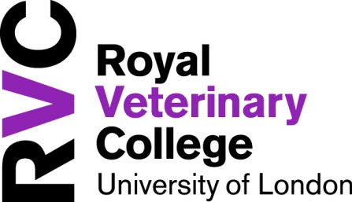

Hawkshead Campus
Student Village
Application Form 2019/2020

Self Catering Accommodation
- £131 per person per week (inclusive of all bills except TV licence)
- Self catering, single study bedrooms with ensuite shower room (6 bed flats perfect for sharing with friends)
- Applications to be made on an individual or group basis (for group applications each student is required to send an application form listing the other students with whom you wish to share)
- Internet and Wifi access in all bedrooms
- Shuttle bus (Monday to Sunday – timetable applies)
- Restricted parking * (see note below)
- Let on a fixed term contract of 46 weeks (September - July)
- Refundable deposit of £300
- Easy access to all on campus facilities

Rent
Each tenant shall pay a total rent of £6026 in 1, 3 or 10 instalments. Method of payment will be via a new online payment portal – further details will be sent in due course.

Important………pls read!
- *The only permanent residents of the New Student Village who will be eligible for a parking permit for the Hawkshead Campus will be BVetMed students once they have started rotations. Parking is only permitted in the designated student car parks.
All other undergraduate students, postgraduates and vet nurses will no longer be automatically eligible for a parking permit. However, you may apply for a permit on the basis of extenuating circumstances to hhparkingpermits@rvc.ac.uk
- Travel subsidy for those students residing in Student Village and studying full time in Camden is no longer available for 2019/2020
- Throughout the next two years, there will be construction of new teaching and research facilities at Hawkshead campus. There will be no building work adjacent to the student accommodation, so we do not anticipate any significant impact on your relaxation. While there will be occasional weekend activity, the vast majority of the project will be conducted during the working day.

Tenant Details
Name  Male/Female*  *delete not applicable | Year :  (from Sept. 2019)  Course :  Campus of study : Hawkshead/Camden*  *delete not applicable
Term Time Address | Home/Alternative Correspondence Address
Home Telephone No.  Mobile No. | Email:
Please give details of any disability or health related requirements: Information given will be treated with the strictest of confidence ________________________________________________________________________________________________________
________________________________________________________________________________________________________
List of students who you would like to share with : (each student is required to send an application form listing the other
students for group application)

1. _____________________________________________________________________________________________________
2. _____________________________________________________________________________________________________
3. _____________________________________________________________________________________________________
4. _____________________________________________________________________________________________________
5. _____________________________________________________________________________________________________
Pls tick box indicating preferred instalment plan
1 Instalment Plan  Full rent payable - prior to tenancy start date of 7th September 2019 (typically 7 days prior) | 3 Instalment Plan  1st instalment - £2008.67 due 7.9.19  2nd instalment - £2008.67 due 4.1.20  3rd instalment - £2008.66 due 25.4.20 | 10 Instalment Plan  10 equal payments of £602.60 due  on the first of each month  October 2019 – July 2020

Returner Applicants Only - Are you requiring accommodation over the summer period Yes No

Do you have any objection with us sharing your name with other prospective occupants of the flat? Yes No

Signature : ________________________________________________ Date : ______________________________________

NOTE : If currently in accommodation, it is NOT guaranteed that a place is automatically assured.
Completed forms must be emailed to accommodation@rvc.ac.uk or returned to Accommodation Office, Hawkshead House, Hawkshead Campus
no later than 17:00 on Friday, 5th April 2019

Any application received after the above closing date will not be considered during the allocation process
but will be added to a waiting list

Outcome of application will be made known by 26th April 2019
Blank Page

