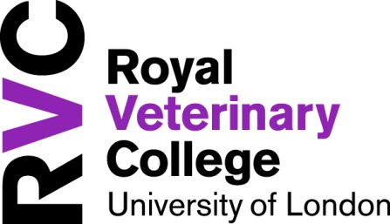
Hawkshead Campus
Student Village 2018/2019
The Student Village comprises of 191 single study bedrooms with ensuite shower rooms, in groupings of 6, arranged within 3 or 4 storey twin pavilion blocks. Each grouping has a kitchen/lounge area and all rooms are provided on a self catering basis. Internet and Wi-Fi access is available in each bedroom.

Some of the facilities on Hawkshead Campus include The Buttery (SU run bar), Eclipse Cafe & Restaurant*, easy access to the new Sports and Wellbeing Centre, sports grounds and multi-use games area, state of the art library and coin operated laundry facilities.

2018/2019 Fees and Contract
We are pleased to offer these rooms for the rate of £126 per week. The contract period is for a fixed term of 46 weeks. Weekly rate is inclusive of all utilities (except TV Licence).

Parking
Residents of the Student Village eligible for a Hawkshead Campus parking permit are BVetMed students on rotations and fifth years. Parking is only permitted in the designated student car parks.

For 2018-19 only, 4th year BVetMed students will also be issued with a permit for the full year.

All other undergraduate students, post graduates and vet nurses will not be automatically eligible for a parking permit, however, you may apply for a permit on the basis of extenuating circumstances to hhparkingpermits@rvc.ac.uk

Shuttle Bus
A free shuttle service is provided to students between the Hawkshead Campus and Potters Bar station (Monday to Sunday). Timetable applies. There is a regular train service between Potters Bar and Kings Cross – the journey taking just 20 minutes!

Support staff
The Hawkshead Campus has 24 hour security, support from the accommodation team, student resident co-ordinators and an onsite maintenance team.

Local area
It is within walking distance of the local village, Brookmans Park and is a couple of miles from the main town of Potters Bar with good access to shops, supermarkets, banks and public transport.

*opening hours apply

For any additional assistance please email
accommodation@rvc.ac.uk

