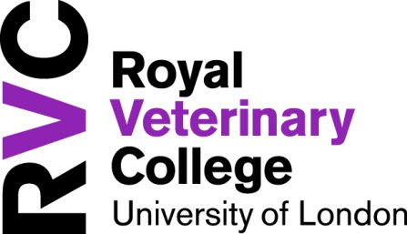

Hawkshead Campus
New Student Village
Application Form 2017/2018

Self Catering Accommodation
- £122.50 per person per week (inclusive of all bills except TV licence)
- Self catering, single study bedrooms with ensuite shower room (6 bed flats perfect for sharing with friends)
- Applications to be made on an individual or group basis (for group applications each student is required to send an application form listing the other students with whom you wish to share)
- Internet and Wifi access in all bedrooms
- Shuttle bus (Monday to Sunday – timetable applies)
- Free parking*
- Let on a fixed term contract of 46 weeks (September to end of July)
- Refundable deposit of £300
- Easy access to the Sports and Wellbeing Centre

Rent

Each tenant shall pay a total rent of £5635.00 in 10 equal instalments of £563.50 on the first day of each month commencing 1st October 2017. This payment MUST be made by standing order.

Information given will be treated with the strictest of confidence.

(*Spaces cannot be guaranteed)

Tenant Details
Name  Male/Female*  *(delete not applicable) | Year (from Sept. 2017)  Course
Term Time Address | Home/Alternative Correspondence Address
Home Telephone No.  Mobile No. | Email:

Please give details of any disability or health related requirements:
List of students who you would like to share with : (each student is required to send an application form listing the other
students for group application)
1. ______________________________________________________________________________________________________
2. ______________________________________________________________________________________________________
3. ______________________________________________________________________________________________________
4. ______________________________________________________________________________________________________
5. ______________________________________________________________________________________________________
Additional Information:

Upon successful allocation of a room do you have any objection with us sharing your name with other occupants of the flat?

YES NO

Signature : ________________________________________________ Date : ______________________________________

NOTE : If currently in accommodation, it is NOT guaranteed that a place is automatically assured.
Completed forms must be returned to Accommodation Office, Estates Department, Hawkshead Campus no later than
21st April 2017

Outcome of application will be known by 28th April 2017

