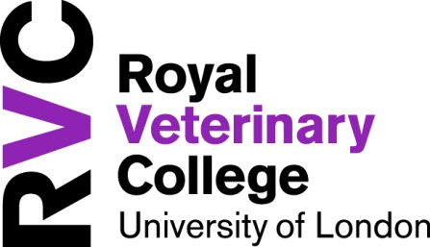
Hawkshead Campus
New Student Village 2017/2018
The New Student Village comprises of 191 single study bedrooms with ensuite shower rooms, in groupings of 6, arranged within 3 or 4 storey twin pavilion blocks. Each grouping has a kitchen/lounge area and all rooms are provided on a self catering basis. Internet and Wi-Fi access is available in each bedroom.

Some of the facilities on Hawkshead Campus include The Buttery (SU run bar), Eclipse Cafe & Restaurant*, easy access to the new Sports and Wellbeing Centre, sports grounds and multi-use games area, state of the art library and coin operated laundry facilities.

Support staff
The Hawkshead Campus has 24 hour security, support from the accommodation team, student resident co-ordinators and an onsite maintenance team who will ensure any problems you may incur whilst in residence, are rectified as soon as possible.

Local area
It is within walking distance of the local village, Brookmans Park and is a couple of miles from the main town of Potters Bar with good access to shops, supermarkets, banks and public transport.

Shuttle Bus
A free shuttle service is provided to students between the Hawkshead Campus and Potters Bar station (Monday to Sunday 8am to 8pm). Timetable applies. There is a regular train service between Potters Bar and Kings Cross – the journey taking just 20 minutes!

2017/2018 Fees and Contract
We are pleased to offer these rooms for the rate of £122.50 per week. The contract period is for a fixed term of 46 weeks. As a resident you are entitled to park on campus (space cannot be guaranteed), weekly rate is inclusive of all utilities (except TV Licence).

Camden Students
To facilitate travel to and from Kings Cross for students studying full time at Camden who are living in the new Student Village, a 25% refund on the cost of a monthly rail season ticket will be available to residents. These tickets are available from First Capital Connect and allow any-time travel between Potters Bar and Kings Cross for the entire calendar month they are valid.

FOR AN APPLICATION FORM
CONTACT THE ACCOMMODATION OFFICE
accommodation@rvc.ac.uk

*opening hours apply

