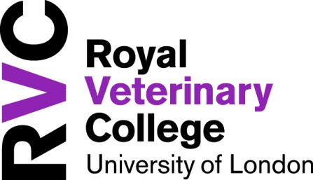
Hawkshead Campus
New Student Village
Application Form 2013/2014

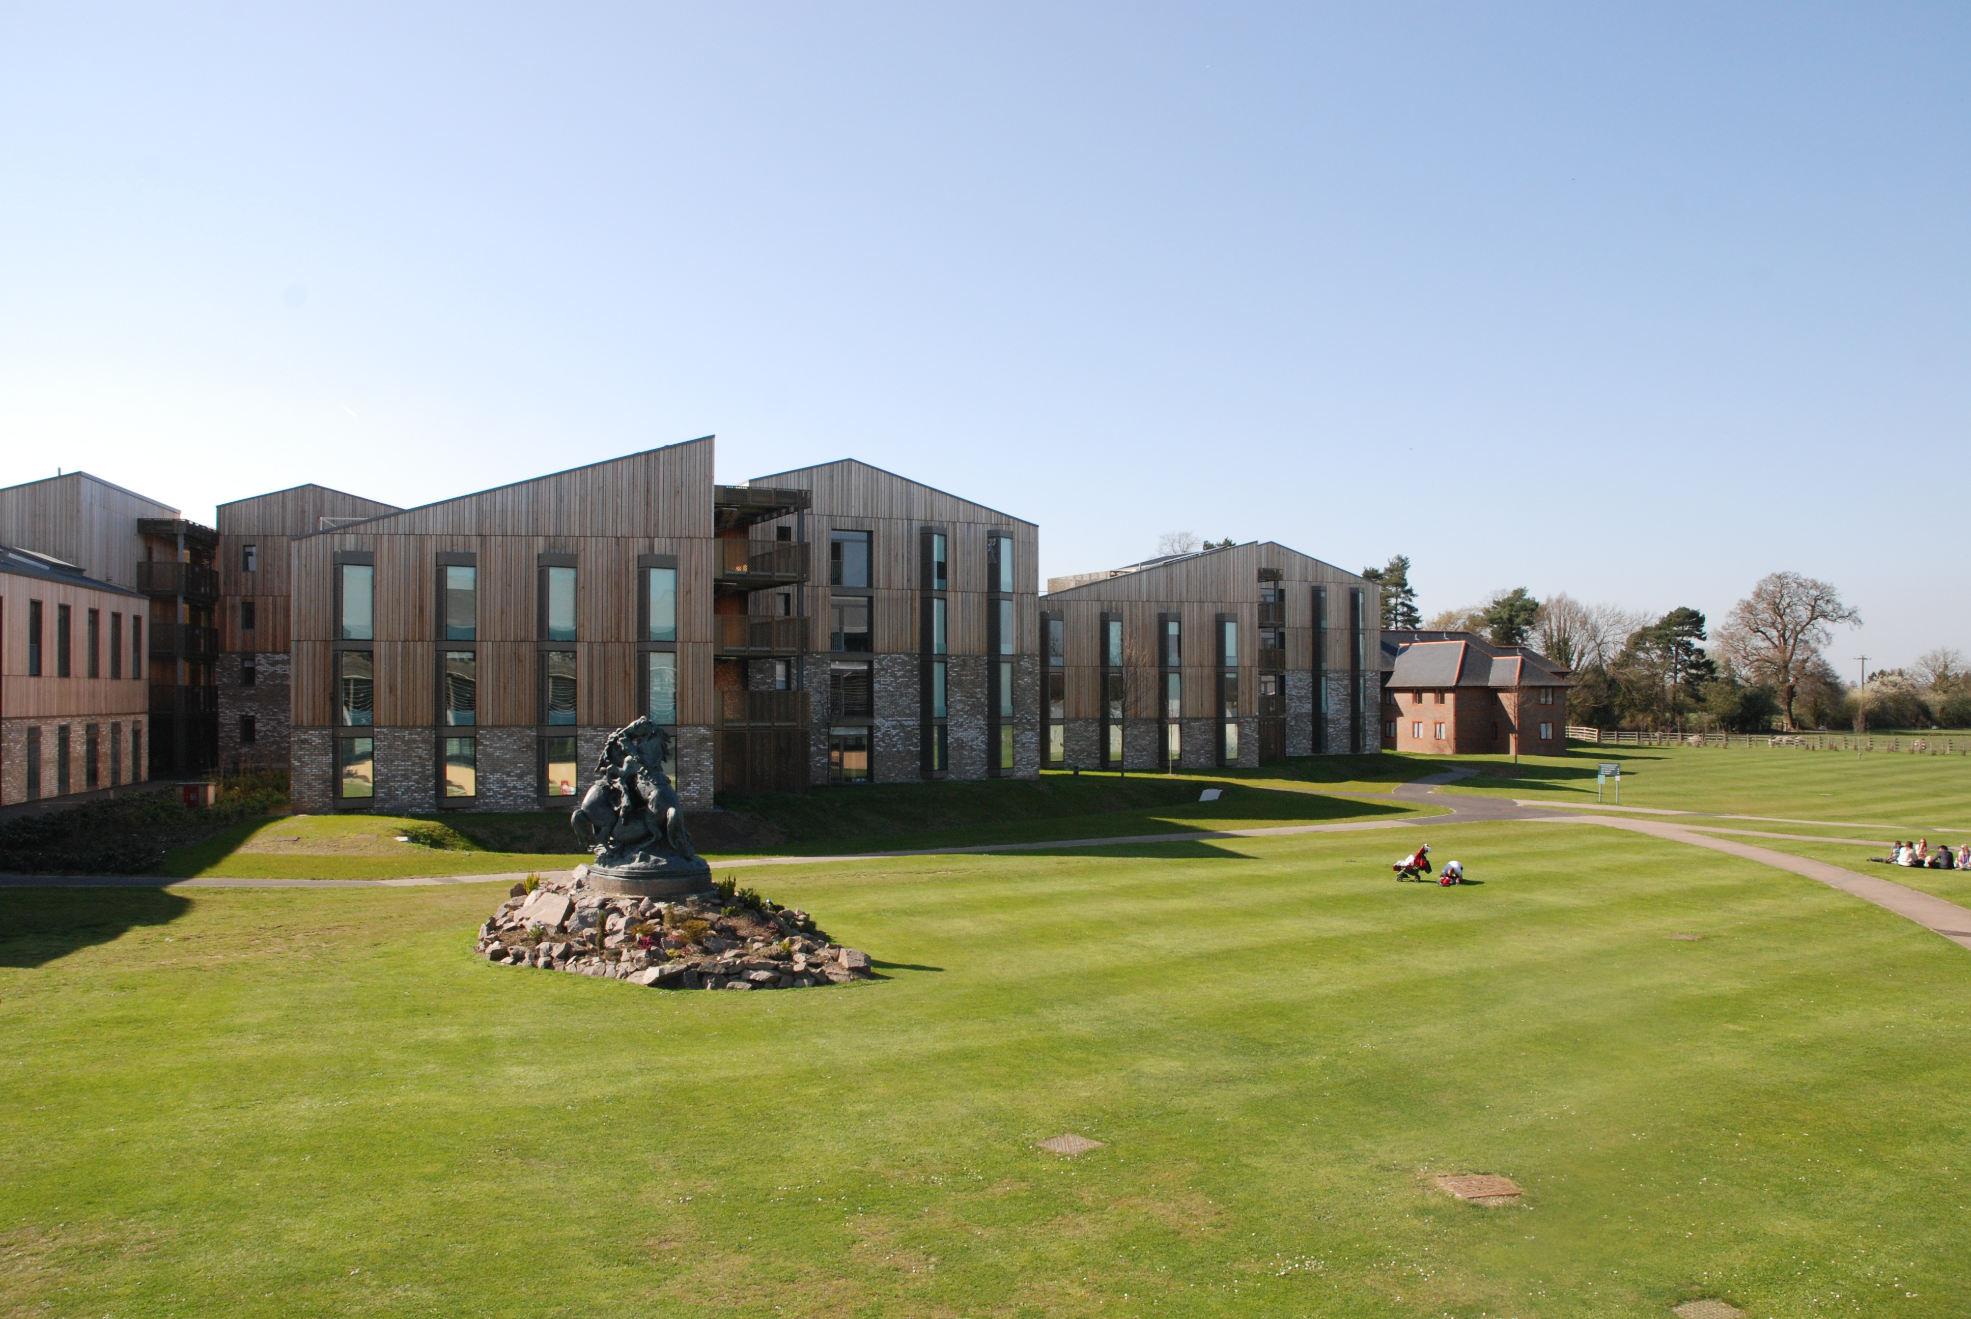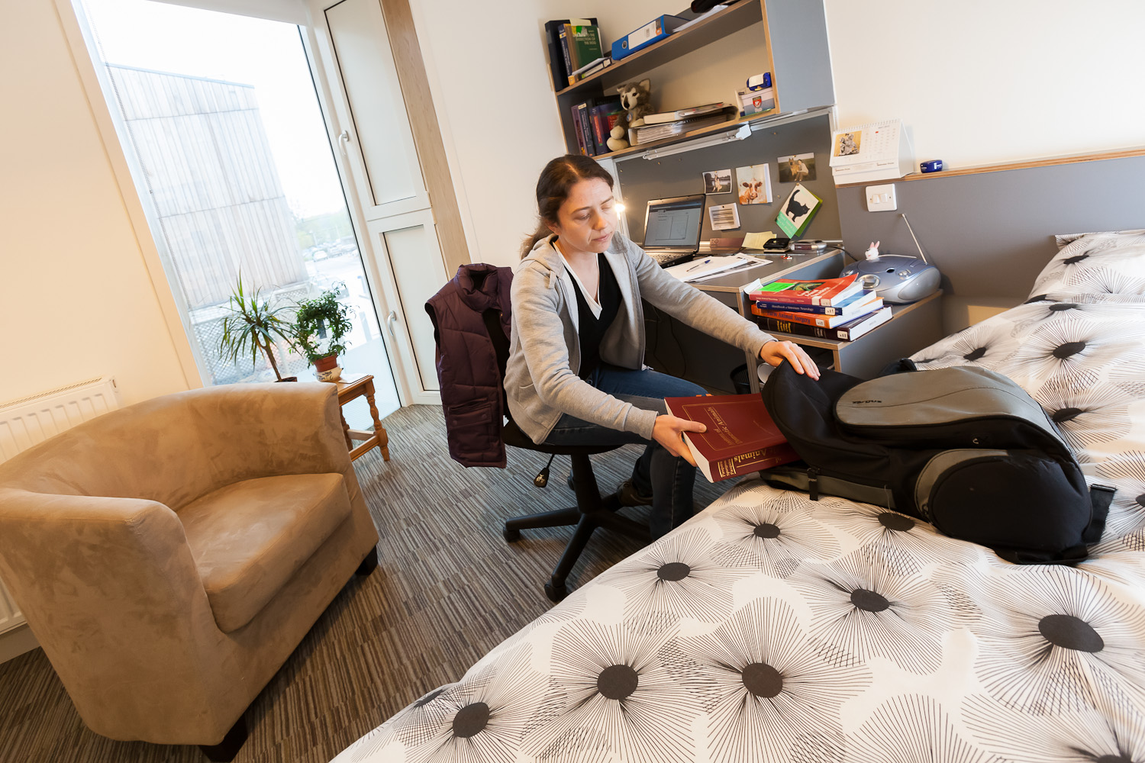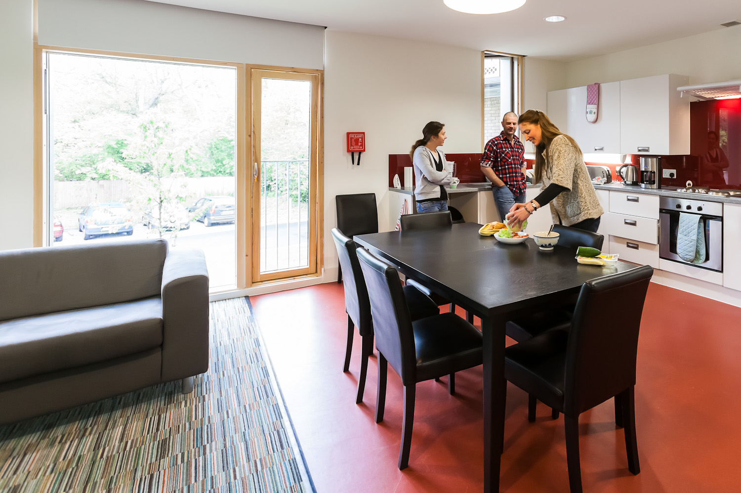

Self Catering Accommodation
- £108 per person per week (inclusive of all bills except TV licence)
- Self catering, single study bedrooms with ensuite shower room (6 bed flats perfect for sharing with friends)
- Applications to be made on an individual or group basis (for group applications each student is required to send an application form listing the other students with whom you wish to share)
- Internet and Wifi access in all bedrooms
- Easy Access to the Brand New Gym
- Free Parking*
- Let on a Fixed Term Contract of 46 weeks (September to end of July)
- Refundable deposit of £496.80

Rent

Each Tenant shall pay a total rent of £4,968 in 10 equal instalments of £496.80 on the first day of each month commencing 1st October 2013. This payment MUST be made by standing order.

(*parking is limited and spaces cannot be guaranteed)
Tenant Details
Name  Male/Female*  *(delete not applicable) | Year (from Sept. 2013)  Course
Term Time Address | Home/Alternative Correspondence Address
Telephone Number: Fax: | Mobile: Email:

Please give details of any disability or health related requirements:
List of students who you would like to share with : (each student is required to send an application form listing the other students for group application)
1. _______________________________________________________________________________________________________
2. _______________________________________________________________________________________________________
3. _______________________________________________________________________________________________________
4. _______________________________________________________________________________________________________
5. ________________________________________________________________________________________________________
Additional Information:

Signature : ___________________________________________________Date : ______________________________________

NOTE : If currently in accommodation, it is NOT guaranteed that a place is automatically assured.
Completed forms must be returned to Accommodation Office, Estates Department, Hawkshead Campus
no later than 26th April 2013

Notification of room allocations will be sent to you by 17th May 2013, along with relevant documentation and details of required holding deposit.

