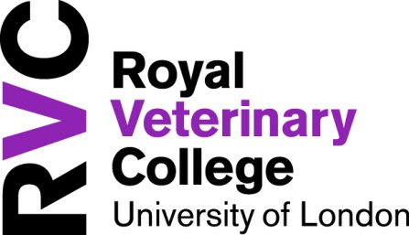
Infrastructure Services Directorate – Estates
APPLICATION FOR RESIDENT COORDINATOR
2020/2021
Please complete this form clearly in black or blue ink and return it to the address supplied at the bottom of this form. All information supplied will be treated confidentially.

Post applied for:
Hawkshead* | College Grove (Camden)* | Mary Brancker House*
*Please delete by selecting one post only

Personal Details

Title (eg. Mr, Mrs, Ms)

Surname

First Name

Year of Study 2020/2021
(1st, 2nd, etc)

Campus of study

Contact Details

Contact Address |  | Contact Telephone Number
Postcode

Email Address

Selection Criteria
The boxes below each contain one of the selection criteria required of the role. In each box please explain how you meet the criteria and where possible provide supporting information.

Criterion A – An awareness of students’ needs and concerns
Criterion B – An ability to communicate effectively
Criterion C – An ability to work as a member of a team
Criterion D – An ability to act tactfully and effectively in difficult situations
Criterion E – An ability to retain confidentiality when dealing with students’ concerns

Criterion F – Availability throughout the term of the Licence Agreement
Criterion G – A willingness to attend training sessions and meetings
Criterion H - Able to demonstrate being calm under pressure
Criterion I - Able to exercise common sense
Criterion J – Able to demonstrate an understanding of equality and diversity and its practical application

Declaration

In accordance with the Data Protection Act 1998 and the general data protection regulation (GDPR) effective 25th May 2018, the information on this form will be used in the selection process. This information may be disclosed to other parties taking part in the selection process. It will also form the basis of the confidential record for the successful candidate. In the case of unsuccessful candidates, the information will be destroyed after 12 months.

I agree that the Royal Veterinary College has the right to validate any of the information provided.

I certify to the best of my knowledge, the information given on this form is correct.

Signature | Date

Please return your application form to Email: accommodation@rvc.ac.uk

In the event of a query please telephone 01707 666 943 or 01707 666 940

